**Create an EC2 Instance Using Terraform:**

1. terraform init

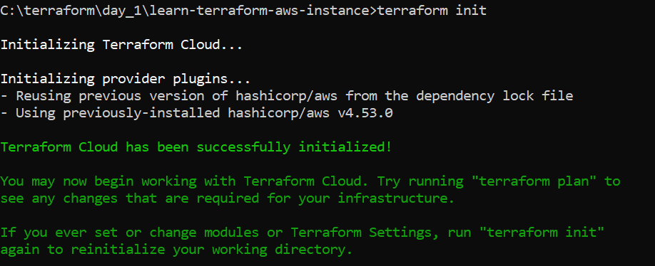

1. terraform validate



1. terraform fmt

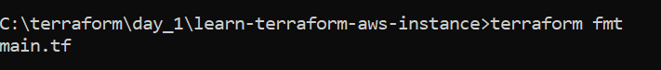

1. terraform plan

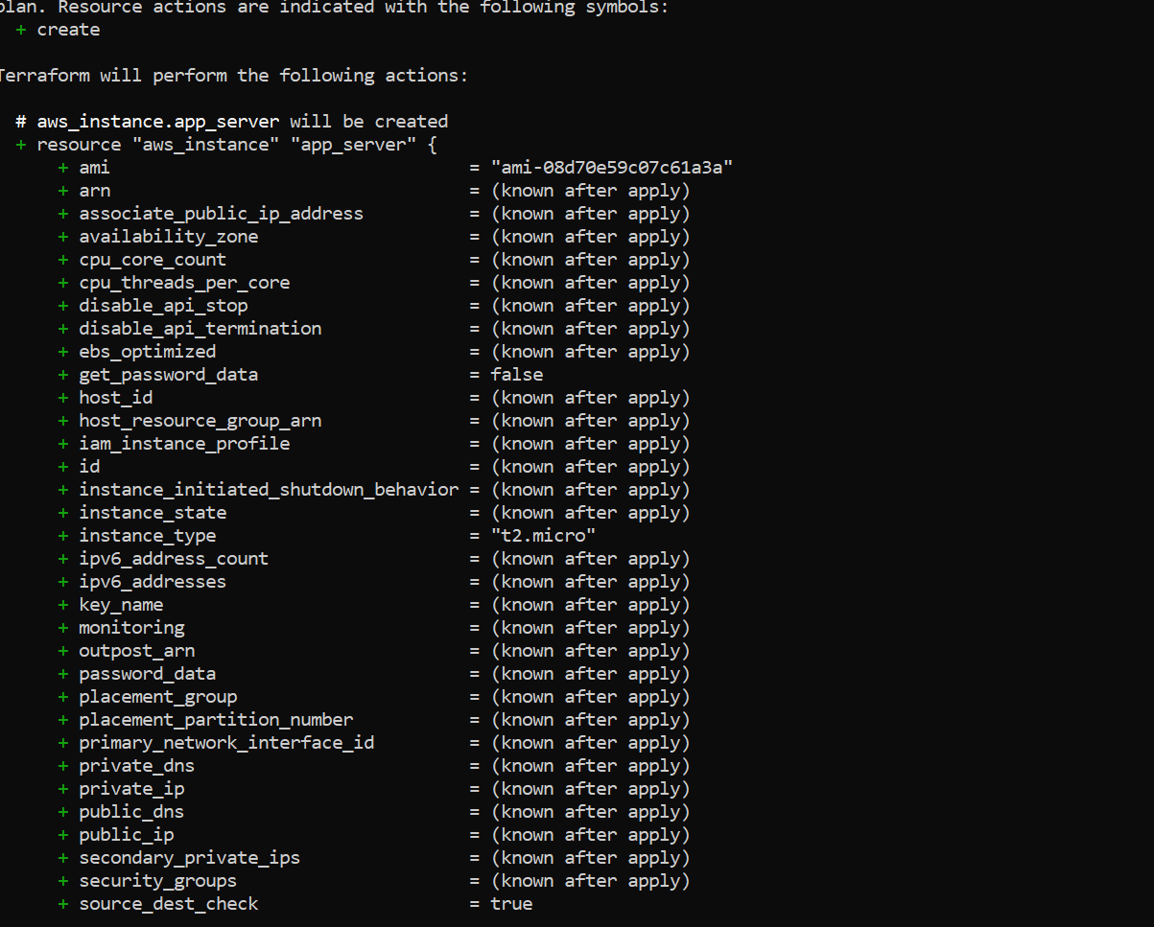

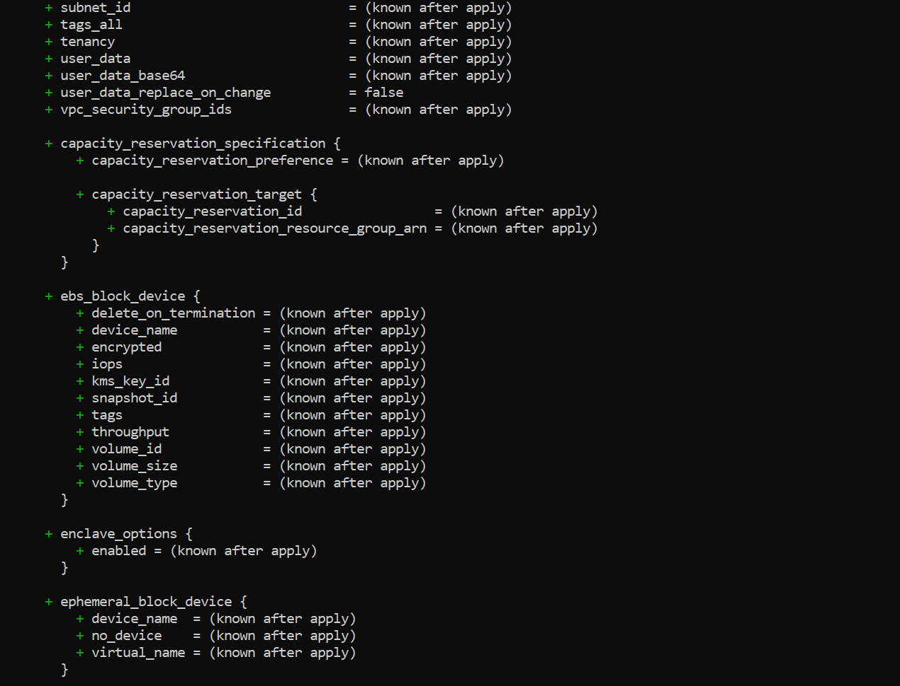

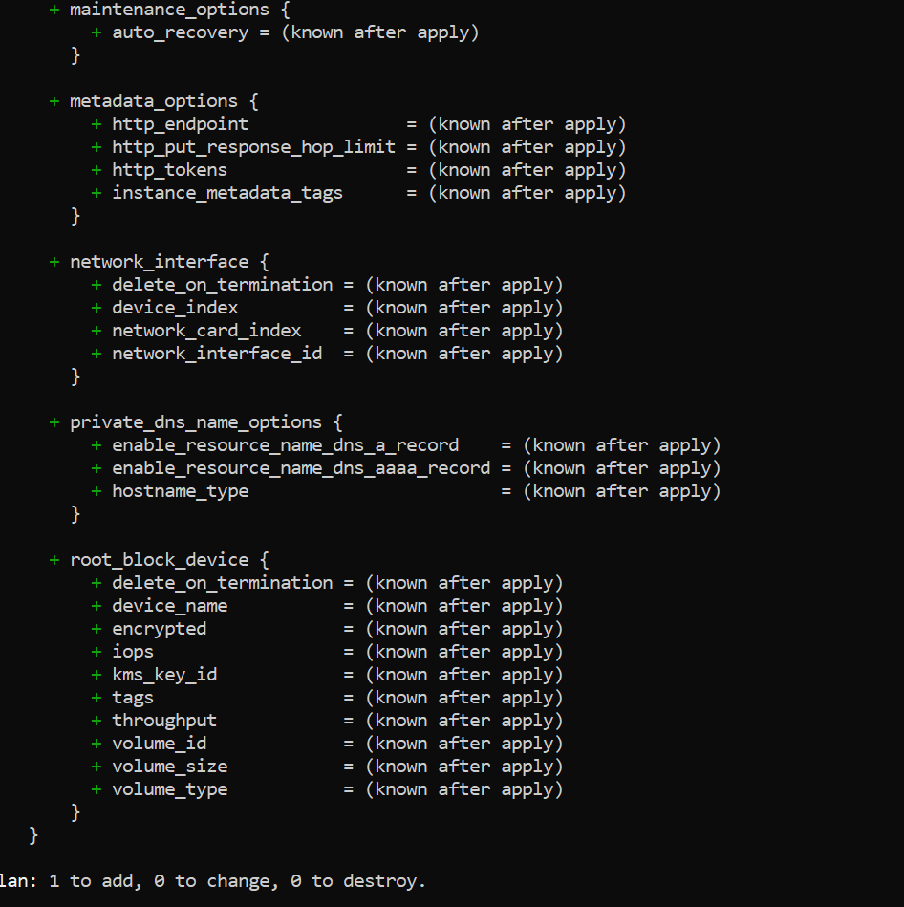

1. terraform apply

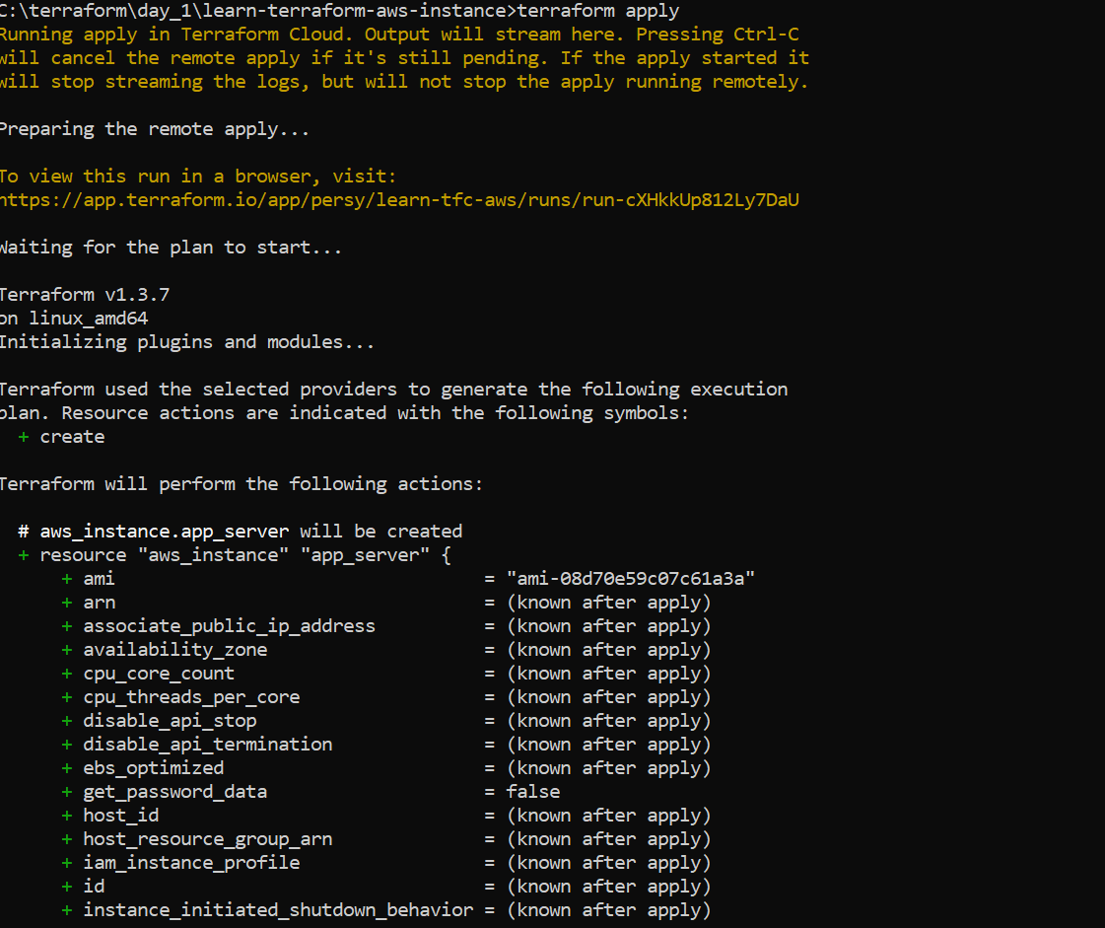

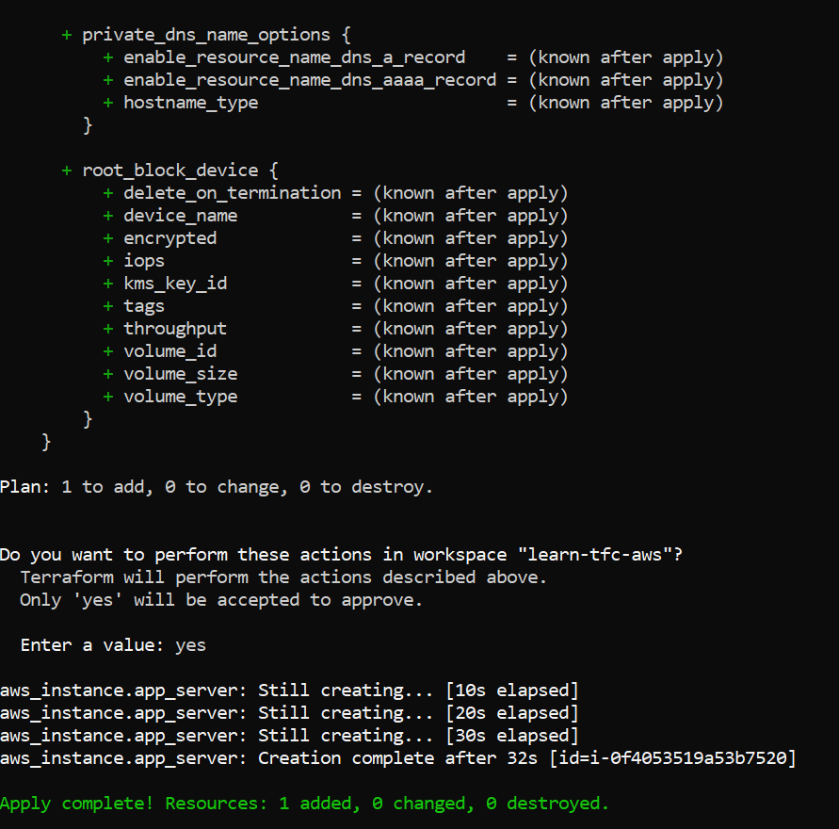

1. terraform output

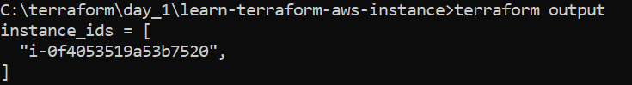

1. terraform show

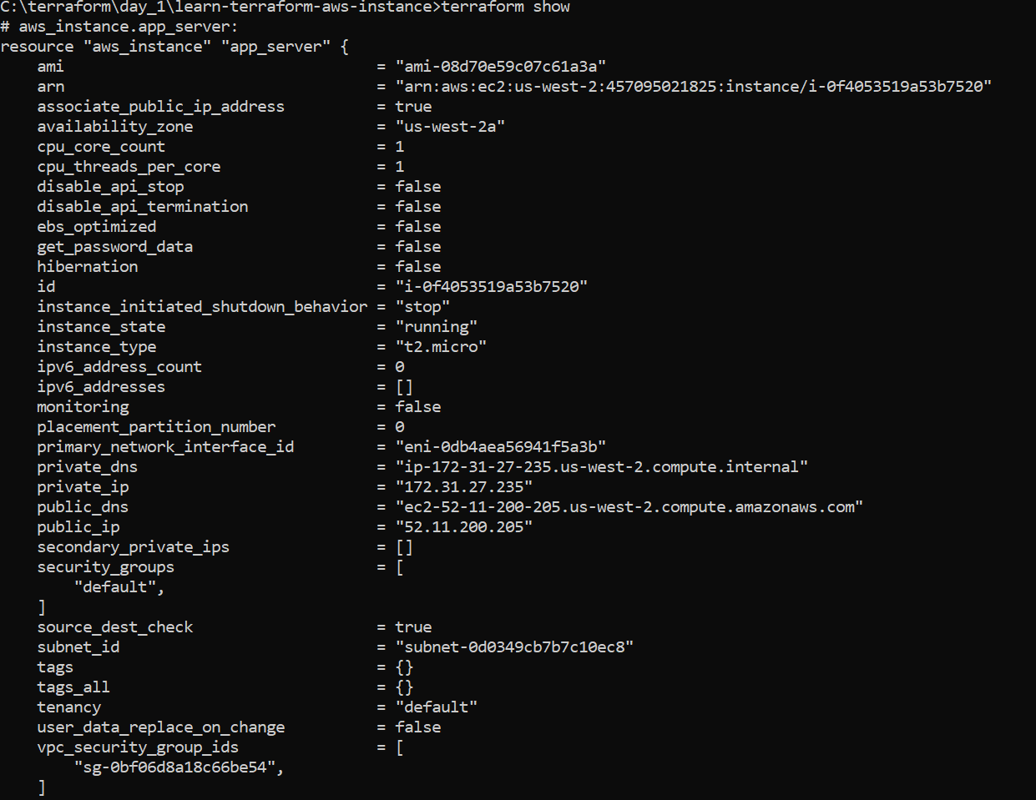

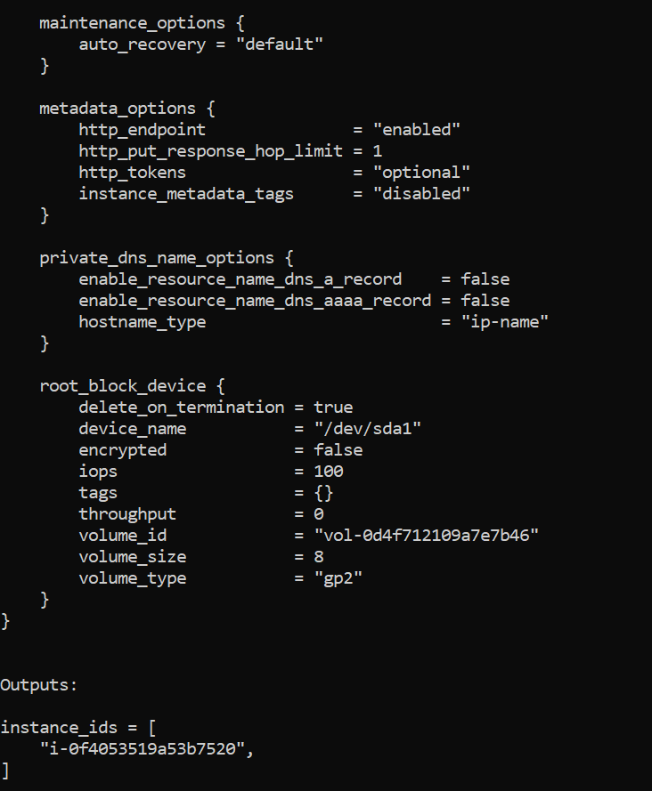

1. terraform destroy

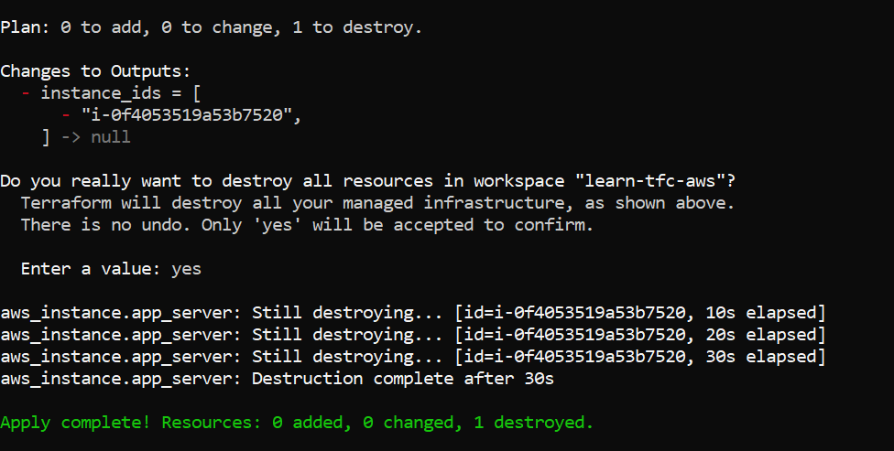

Instance will be terminated as below:

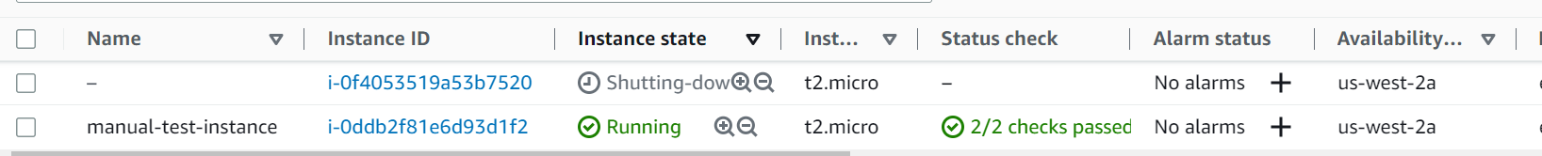

**Create instance using manually and using terraform**

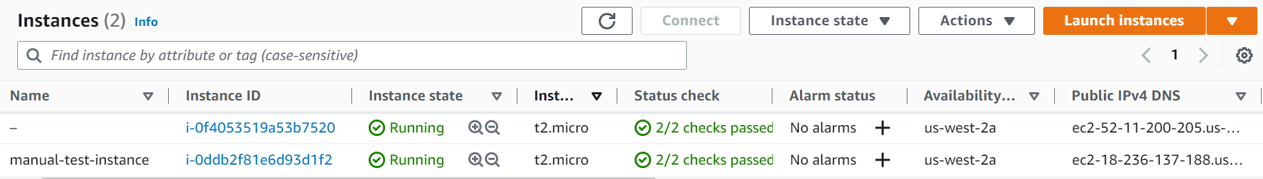



**Terminate instance using terraform:**



**Terminate instance manually:**

